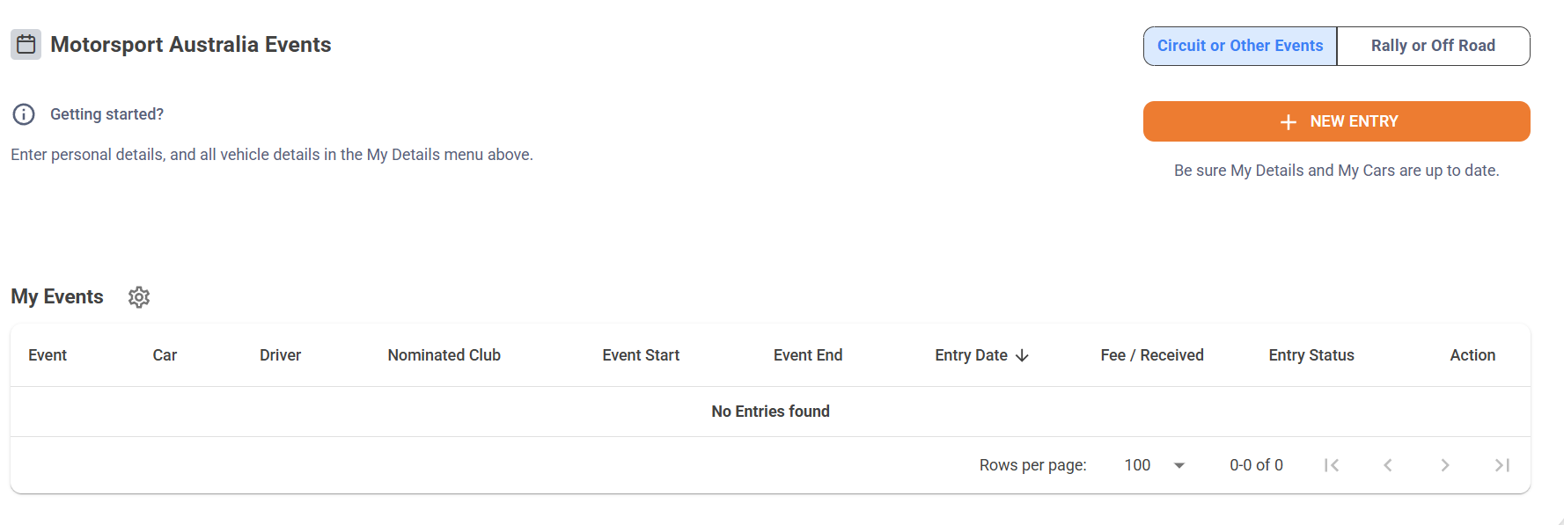

Entry Screen

Search for Khanacross

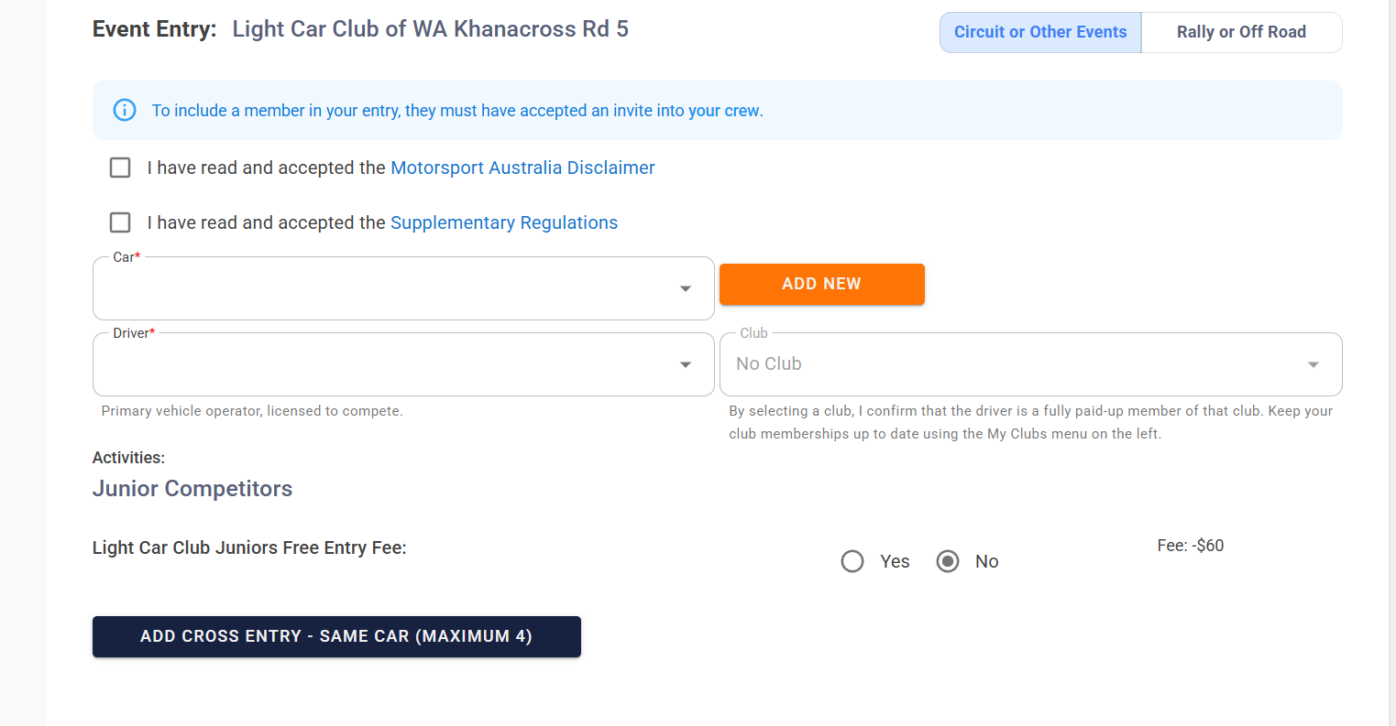

Tick the ma Disclaimer box and supp regs box Select vehicle, driver, car club, and if Light Car Club Junior and then select add cross entry box at bottom of screen.

Select amount of lunches if none just leave blank then select confirm without paying or confirm and pay for entry to go through.