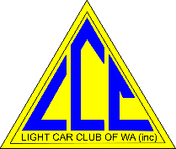

Safari Rally Sprint - Sunday 5th Octobr2025
Competitors advise
The location of trailer parking and Assembly area is at the powerline track on Chidlow Rd Sawyer Valley,
Chidlow Road is off Great Eastern Highway

Please be aware of 4WD using the powerline track and take care not to block the track
Attached is map indicating Locations of Trailer parking and
Assembly area for start of Stage SS1 & SS2

Assembly area for start of SS3 & SS4.

Wendy Walker
Clerk of Course
Safari Rally Sprint 2025

