 | 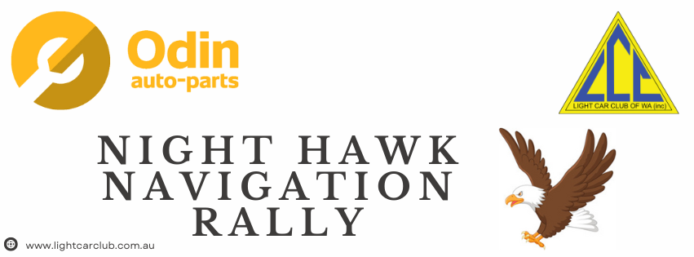
Navigator |  | Drivers |  | Vehicle make
Lachlan | McLagan | Stuart | McLagan | Toyota | Hilux 2013
Tina | Price | David | Price | BMW | F10 2014
Martin | Hallam | Mark | Hallam | Isuzu | Mux 2024
Ben | Whitaker | Ian | Whitaker | Land Rover | Defender 2013
Amelia | Jordan | Grahame | Jordan | Mitsubishi | Lancer
Elliot | Hannigan | Andrew | Hannigan | Toyota | Sprinter 1984
Mitch | Orchard | David | Orchard | Toyota | Landcruiser 2012
Chloe | Smith | Douglas | Smith | Jeep | Grand Cherokee
Ben | Devries | Corey | Smith | VW | Golf 2009
Diarmuid | Donovan | Magz | Donovan | Isuzu | D Max 2021
SHAUN | MC MACKEN | GLENN | ALCORN | TOYOTA | CAMRY 2004
Susan | Korzec | Simon | Korzec | Land Rover | Discovery

